English / Portuguese / French / Thai / Vietnamese / Spanish

English

Brief:
An email sent to partners who have attended the event. This email will include a photo gallery It will be sent via customer.io

Target audience:
Event attendees

Subject: Thank you for coming to [EVENT NAME]!

You made our event a success! 🎉

Hi [PARTNER NAME],

Thank you for attending [EVENT NAME] in [CITY], [COUNTRY]. We hope you had a great time, and it was a pleasure getting to know you!

For pictures and highlights from the conference/seminar/affiliate trip and to stay updated on our latest events and initiatives for you, follow us on:

 | 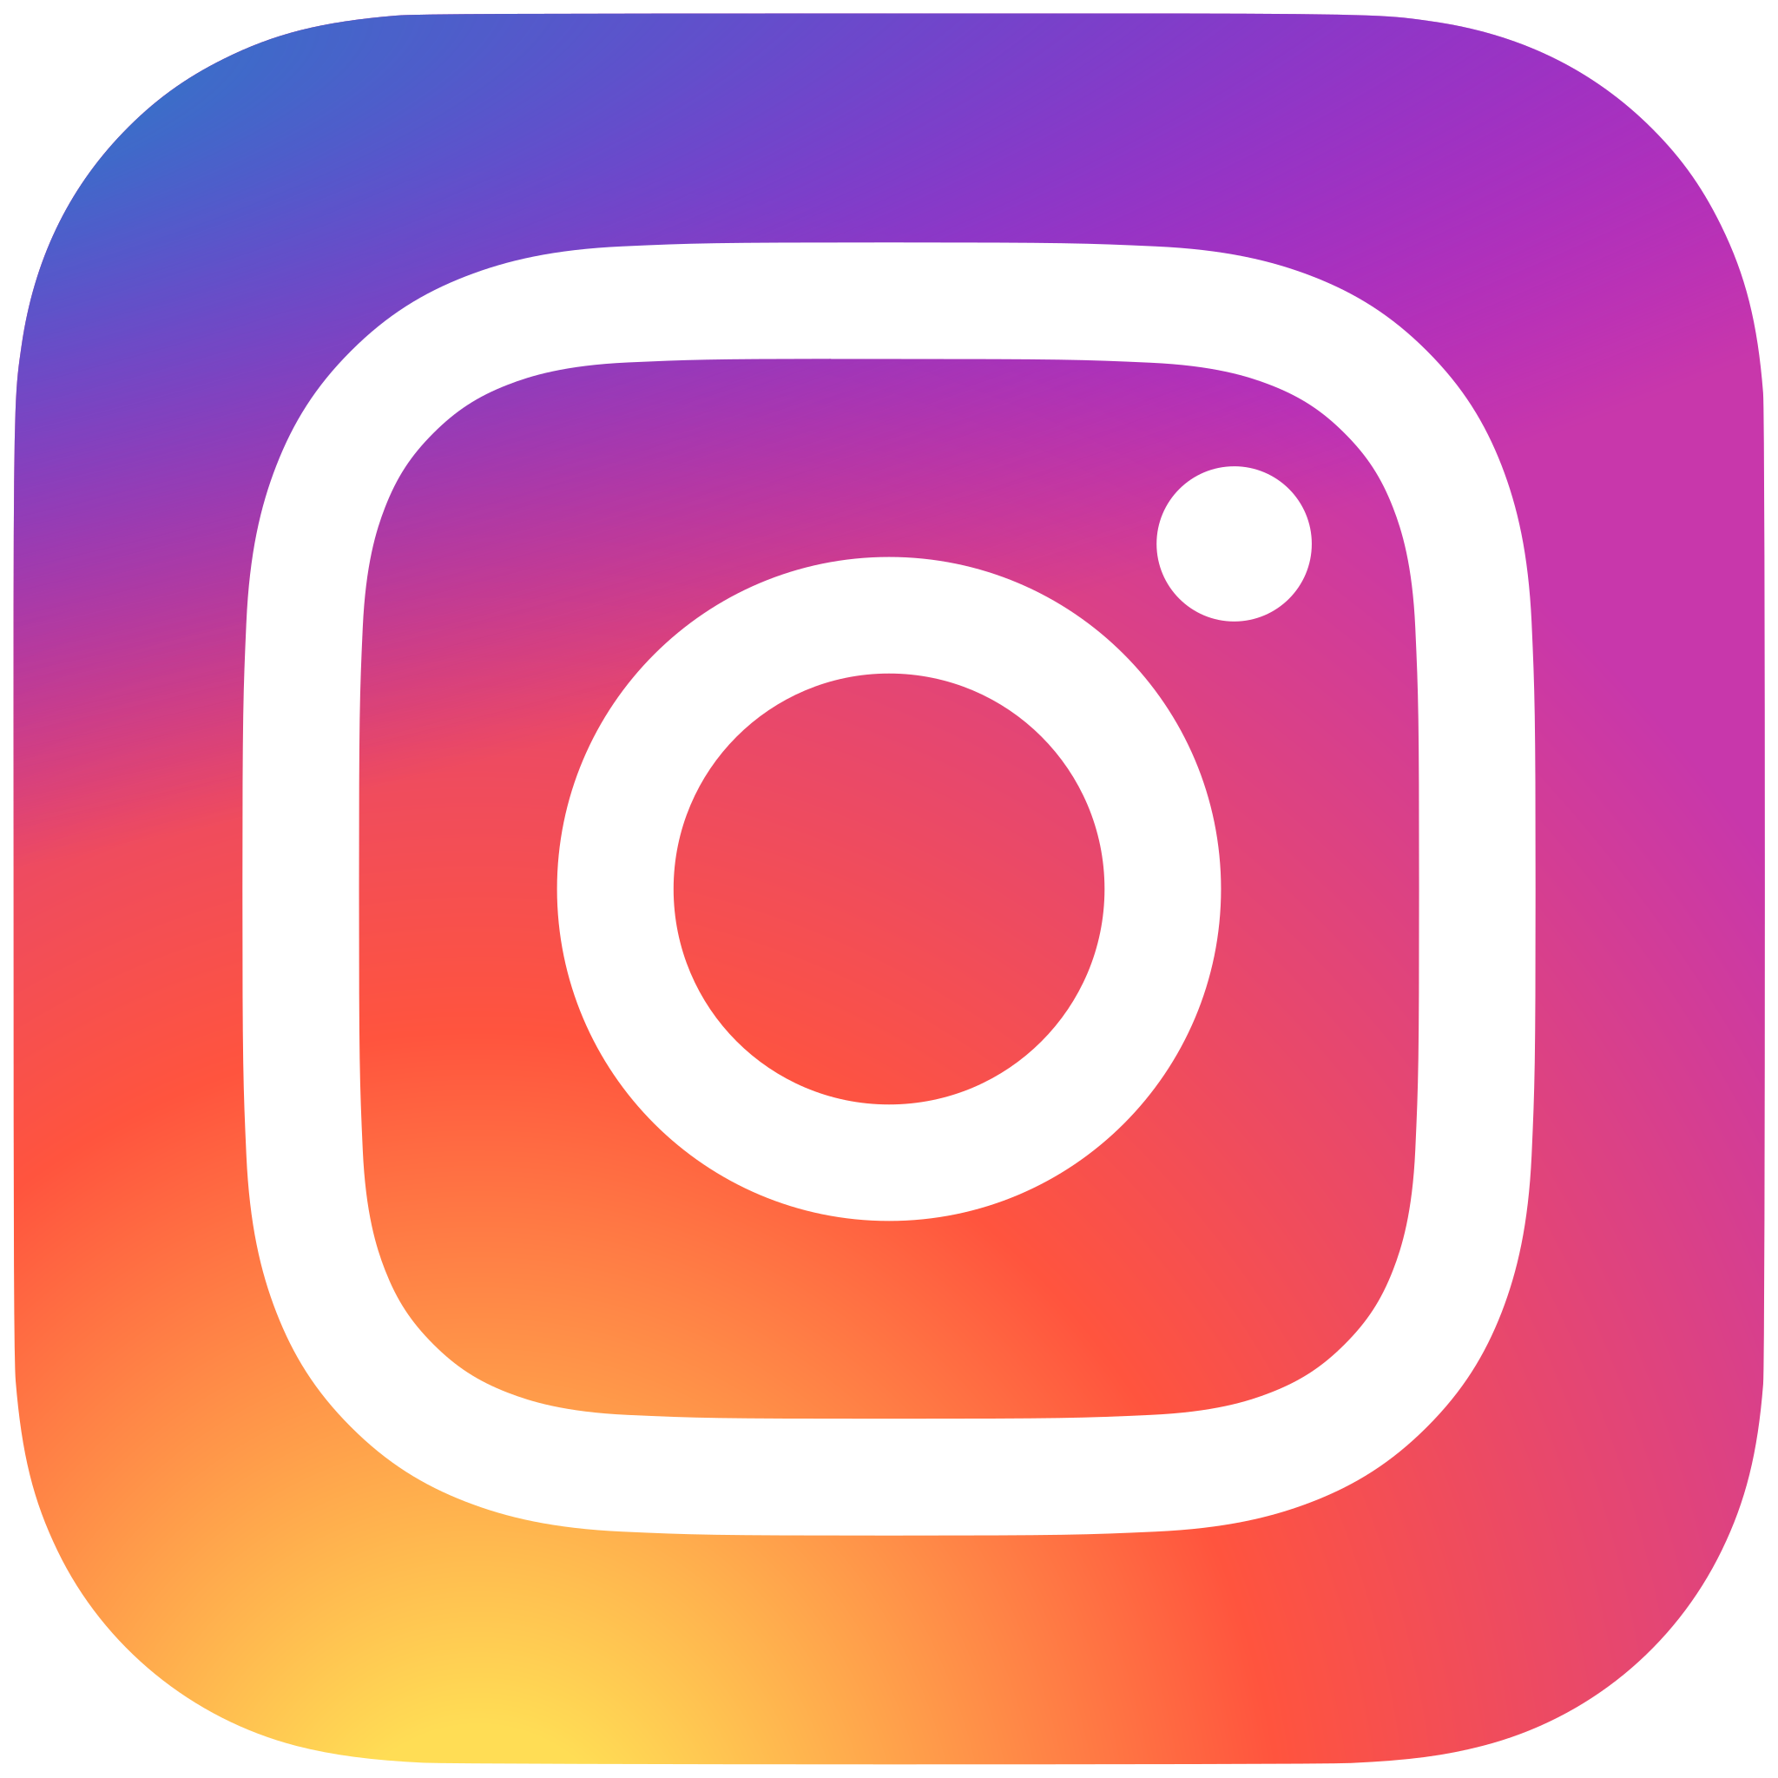 | 
We hope the event inspired you as much as it did us, and let’s keep growing together!

